SOC Detection Engineering Lab
Windows Brute-Force Attack Detection
Using Wazuh SIEM / XDR

Prepared by
Paulson K Babu

Cybersecurity Enthusiast | SOC Analyst Aspirant

Date: February 11, 2026

Platform | Wazuh SIEM / XDR
Classification | Lab / Educational Use
MITRE Technique | T1110 — Brute Force
Alert Level | Level 12 — Critical

1. Executive Summary
This document details the configuration, testing, and validation of a custom brute-force detection rule in Wazuh SIEM. Initially, individual Windows authentication failures were logged as standard 'login failed — bad username or password' events with no correlation performed.
After implementing a frequency-based correlation rule using if_matched_sid in local_rules.xml, multiple failed login attempts within a defined timeframe were successfully escalated as a high-severity brute-force alert (Level 12). The alert was validated in both the Wazuh Discover view and the Threat Hunting Dashboard.
This exercise demonstrates practical SOC detection engineering skills including log correlation, custom rule development, MITRE ATT&CK mapping, and alert validation — all core competencies of a Tier 1/2 SOC Analyst.

2. Objectives
- Understand how Windows authentication failures are logged and processed by Wazuh SIEM.
- Create and deploy a custom frequency-based correlation rule in local_rules.xml.
- Detect brute-force behavior by correlating multiple failed login events within a defined timeframe.
- Validate real-time alert generation in the Wazuh Dashboard (Discover and Threat Hunting views).
- Map the detection rule to the MITRE ATT&CK framework (Technique T1110 — Brute Force).
- Troubleshoot and resolve Wazuh configuration errors encountered during implementation.

3. Lab Environment

Wazuh Manager | Installed on Linux server — processes rules, correlates events, generates alerts
Wazuh Agent | Installed on Windows endpoint — collects and forwards Security Event Logs
Log Source | Windows Security Event Logs (Event ID 4625 — Failed Logon)
Dashboard | Wazuh Web Interface — Discover Module and Threat Hunting view
Rule File | /var/ossec/etc/rules/local_rules.xml
Custom Rule ID | 100200
Detection Method | Frequency-based correlation — 3 failures within 120 seconds

4. Initial Observation — Before Custom Rule
Before implementing the custom correlation rule, each Windows failed login attempt was logged individually by Wazuh with the description 'Login failed — bad username or password'. No event correlation was performed, meaning no brute-force alert was generated regardless of how many failed attempts occurred.
This is the default behavior of Wazuh's built-in rules — they detect individual events but do not aggregate them into attack patterns. The screenshots below show these individual failed login events as they appeared in the Wazuh Dashboard before any custom rule was applied.

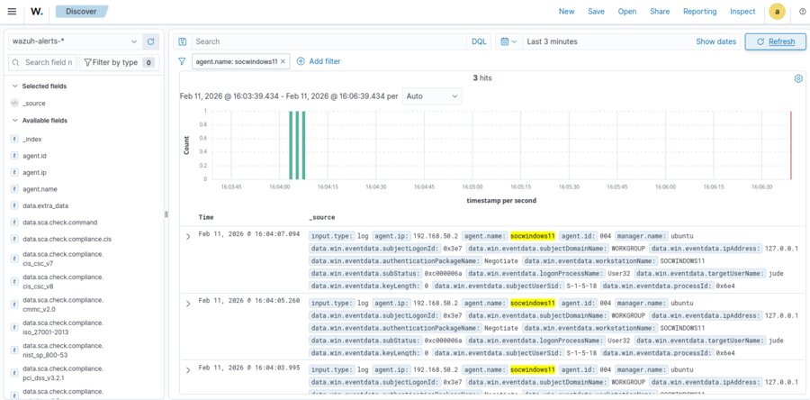
Figure 1: Individual failed login events in Wazuh Dashboard — no correlation, no brute-force alert generated

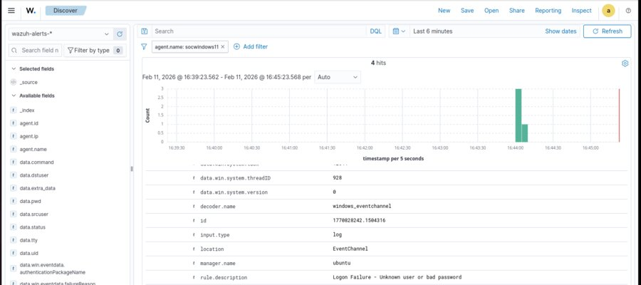
Figure 2: Additional view of individual failed Windows authentication events before custom rule implementation

5. Custom Correlation Rule Implementation
A frequency-based detection rule was added to the local_rules.xml file on the Wazuh Manager. This rule detects three or more failed Windows login attempts originating from the same source within a 120-second window and escalates them as a brute-force alert with Level 12 (Critical) severity.

5.1 Rule Configuration
Two variations of the rule were tested during implementation:
Variation 1 — Using if_matched_group:
<rule id="100200" level="12" frequency="3" timeframe="120">
<if_matched_group>authentication_failed</if_matched_group>
<description>Multiple Windows login failures detected. Possible brute-force attack.</description>
<mitre><id>T1110</id></mitre>
</rule>

Variation 2 — Using if_matched_sid (Recommended):
<rule id="100200" level="12" frequency="3" timeframe="120">
<if_matched_sid>60122</if_matched_sid>
<description>Multiple Windows login failures detected. Possible brute-force attack.</description>
<mitre><id>T1110</id></mitre>
</rule>

5.2 Rule Parameters

Rule ID | 100200
Frequency | 3 (three failed logins required to trigger)
Timeframe | 120 seconds
Severity Level | 12 — High / Critical
Parent Rule (SID) | 60122 — Windows failed authentication
MITRE Technique | T1110 — Brute Force
Rule File | /var/ossec/etc/rules/local_rules.xml

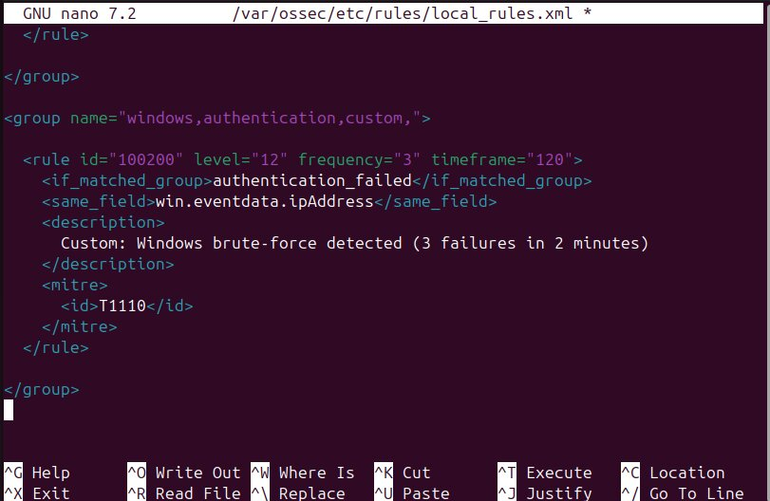
Figure 3: Custom correlation rule added to local_rules.xml — frequency=3, timeframe=120s, level=12

6. Applying Configuration Changes
After saving the custom rule to local_rules.xml, the Wazuh Manager service was restarted to load the new configuration. This step is required for any rule changes to take effect.
Command executed:
sudo systemctl restart wazuh-manager

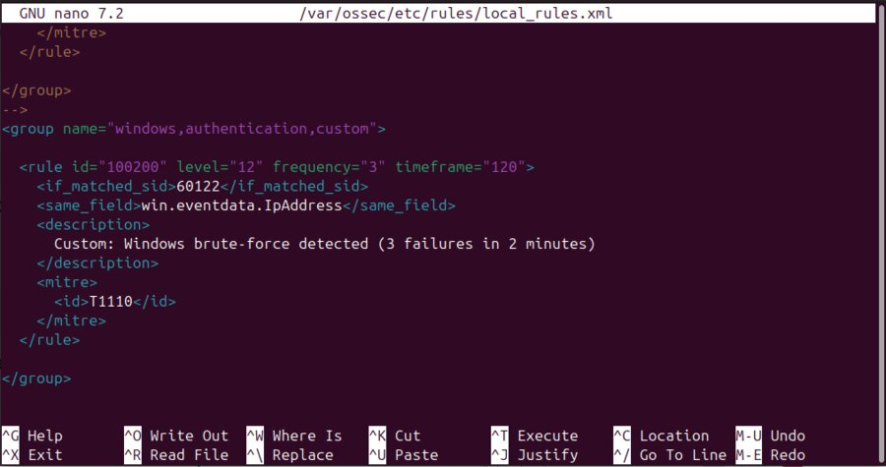
Figure 4: Wazuh Manager service restarted successfully to apply the custom rule configuration

7. Key Concept — if_sid vs if_matched_sid
Understanding the difference between these two directives is critical for writing correct frequency-based correlation rules in Wazuh:

if_sid | Triggers the rule IMMEDIATELY when a single event matches the specified rule ID. Cannot be used with frequency-based correlation.
if_matched_sid | Used to COUNT multiple occurrences of a matching rule ID within a defined timeframe. Required for frequency-based brute-force detection.
Error if misused | Using if_sid with a frequency attribute causes: 'Invalid use of frequency' error on Wazuh Manager restart.
Correct approach | Always use if_matched_sid when frequency and timeframe attributes are present in the rule.

8. Troubleshooting — Wazuh Restart Error
During the initial implementation, Variation 1 of the rule used if_sid instead of if_matched_sid. When the Wazuh Manager was restarted, an error was encountered:
ERROR: Invalid use of frequency. Cannot use <if_sid> with frequency attribute.

Root Cause:
The if_sid directive triggers on a single event match and does not support counting multiple occurrences. Frequency-based correlation requires if_matched_sid which is specifically designed to aggregate events over time.

Resolution:
- Identified the error in the Wazuh Manager logs.
- Replaced if_sid with if_matched_sid in local_rules.xml.
- Saved the corrected rule file.
- Restarted Wazuh Manager: sudo systemctl restart wazuh-manager
- Manager restarted successfully with no errors.

9. Brute-Force Attack Simulation
To validate the detection logic, three consecutive failed login attempts were performed manually on the Windows endpoint within 120 seconds. This simulated the behavior of an attacker attempting to guess credentials through repeated authentication attempts.

9.1 Event Flow
- Failed login attempts were made on the Windows endpoint.
- Windows generated Security Event ID 4625 (Failed Logon) for each attempt.
- Wazuh Agent on Windows forwarded the events to the Wazuh Manager.
- Wazuh Manager matched events against built-in rule 60122 (Windows failed authentication).
- Custom rule 100200 correlated three matching events within the 120-second timeframe.
- A Level 12 Critical brute-force alert was generated and sent to the Dashboard.

10. Alert Validation — Wazuh Discover View
After three failed login attempts were made within 120 seconds, Wazuh successfully generated a high-severity brute-force alert. The alert was visible in the Wazuh Discover module with the following details:

Rule ID | 100200
Severity Level | 12 — Critical
Description | Multiple Windows login failures detected. Possible brute-force attack.
MITRE Technique | T1110 — Brute Force
Agent | Windows Endpoint
Trigger Count | 3 failed logins within 120 seconds

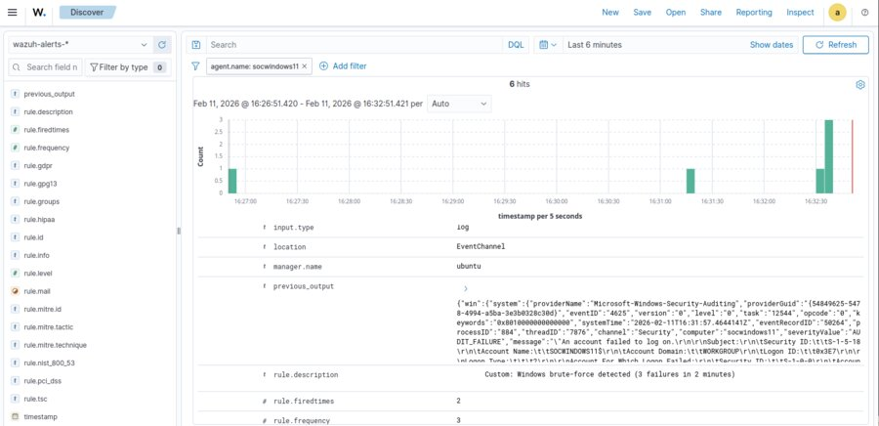
Figure 5: Brute-force alert (Rule ID 100200, Level 12) triggered in Wazuh Discover view

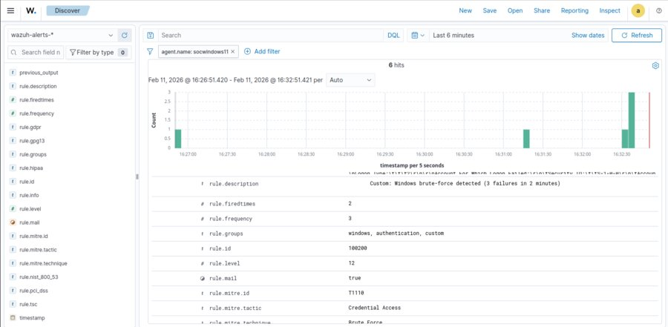
Figure 6: Detailed alert view in Wazuh Discover — MITRE T1110 mapping and alert description visible

11. Validation — Threat Hunting Dashboard
The Threat Hunting Dashboard in Wazuh provided a before-and-after comparison clearly demonstrating the impact of the custom correlation rule. Before the rule was implemented, only individual low-severity events were visible. After correct implementation with if_matched_sid, the Level 12 Critical brute-force alert appeared.

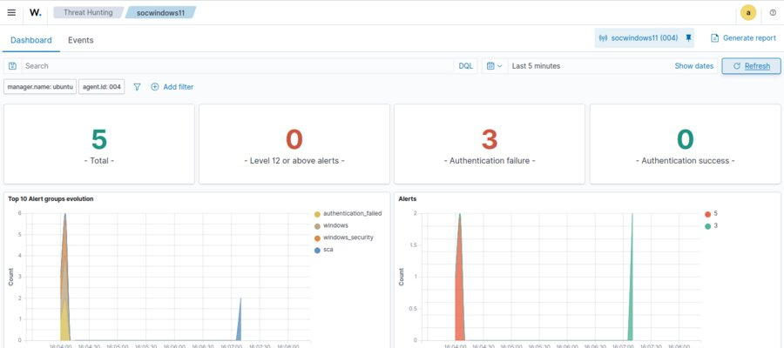
Figure 7: Threat Hunting Dashboard — before custom rule, only individual login failure events visible

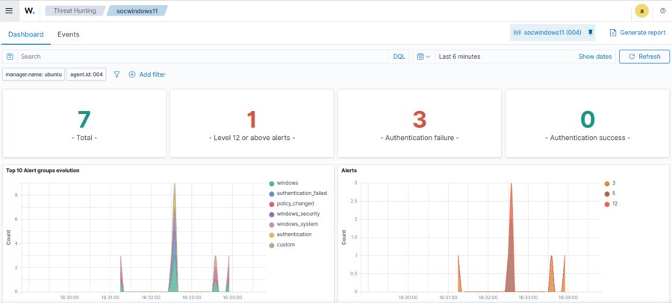
Figure 8: Threat Hunting Dashboard — after custom rule, Level 12 Critical brute-force alert successfully generated

12. Technical Analysis
This implementation demonstrates how Wazuh performs event correlation using frequency and timeframe logic — a core technique used in production SOC environments to detect attack patterns while reducing alert fatigue.

12.1 How the Correlation Works
- Wazuh's built-in rule 60122 fires once for every individual Windows failed login event (Event ID 4625).
- The custom rule 100200 watches for rule 60122 to fire three or more times within 120 seconds from the same source.
- When the threshold is met, rule 100200 fires a Level 12 alert, escalating isolated events into a meaningful brute-force detection.
- This aggregation approach reduces noise while ensuring real attack patterns are not missed.

12.2 Why This Matters in a Real SOC
- Without correlation: An analyst would see dozens of individual low-severity login failure alerts — this is alert fatigue.
- With correlation: A single high-severity brute-force alert is raised, making triage faster and more accurate.
- MITRE ATT&CK mapping to T1110 helps SOC teams understand the attack technique and reference standard response playbooks.

13. Key Learnings
- Understood the difference between single-event rules (if_sid) and frequency-based correlation rules (if_matched_sid) in Wazuh.
- Gained practical experience editing local_rules.xml to create custom detection logic.
- Learned how to correctly configure frequency and timeframe attributes in Wazuh rules.
- Practiced troubleshooting Wazuh Manager restart errors by reading error logs and correcting rule syntax.
- Applied MITRE ATT&CK framework mapping (T1110) to a custom detection rule.
- Validated alert generation in both the Discover module and Threat Hunting Dashboard.
- Experienced the complete SOC detection engineering workflow: Configure → Restart → Simulate → Validate → Document.

14. Conclusion
This lab successfully demonstrated the end-to-end process of building and validating a custom brute-force detection rule in Wazuh SIEM. By implementing a frequency-based correlation rule using if_matched_sid, the system correctly identified three consecutive failed Windows login attempts within 120 seconds and generated a Level 12 Critical alert mapped to MITRE ATT&CK technique T1110.
The exercise also reinforced the importance of understanding Wazuh's rule architecture — specifically the distinction between if_sid and if_matched_sid — and provided practical experience in troubleshooting configuration errors that arise during real-world SOC operations.
The skills demonstrated in this project — custom rule development, event correlation, alert validation, MITRE ATT&CK mapping, and systematic troubleshooting — are directly applicable to entry-level SOC Analyst and Detection Engineer roles and represent a strong addition to a cybersecurity professional portfolio.

15. References
- Wazuh Documentation. (2024). Custom Rules. https://documentation.wazuh.com/current/user-manual/ruleset/custom.html
- Wazuh Documentation. (2024). Wazuh Rules Syntax. https://documentation.wazuh.com/current/user-manual/ruleset/rules-classification.html
- MITRE ATT&CK. (2024). T1110 — Brute Force. https://attack.mitre.org/techniques/T1110/
- Microsoft Docs. (2024). Windows Security Event ID 4625 — An account failed to log on. https://docs.microsoft.com/en-us/windows/security/threat-protection/auditing/event-4625
- NIST SP 800-92. (2006). Guide to Computer Security Log Management. National Institute of Standards and Technology.

